Olu Afolabi
EECE 412
Professor Wenjie
3/20/2025
Lab 7
Introduction
In this lab, the objective was to explore and implement fundamental digital design structures using the case statement in VHDL. Specifically, we focused on designing a 4-to-1 multiplexer and a 2-to-4 decoder, both of which are common building blocks in digital systems. While previous labs used selected signal assignment statements (with...select), this lab demonstrates an alternative method using case statements within process blocks. The shift to case statements allows more flexibility and supports the development of more scalable control structures. Through this exercise, we gained practical experience with behavioral modeling and learned how control signals can be decoded and used to select outputs in a structured and readable VHDL format. The implementation was synthesized, and the resulting schematic was analyzed to confirm accurate logic generation.
Concept
This lab focuses on the use of the case statement, a control construct in VHDL that enables decision-making based on the value of a signal. Unlike the with signal select, which provides a compact syntax for signal assignment, the case statement is used within a process block and offers more descriptive and expandable logic control.
Two core digital circuits are explored:
- 4-to-1 Multiplexer (MUX):
  - A MUX selects one of several input signals and forwards it to a single output line.
  - In the 4-to-1 MUX implemented here, four data inputs (a, b, c, d) are controlled by a 2-bit select signal s.
  - Depending on the value of s, one of the inputs is routed to the output x.
- 2-to-4 Decoder:
  - A decoder activates exactly one output bit based on a binary input.
  - With a 2-bit input s, the decoder sets one of four outputs (y[3:0]) high, while the others remain low.
  - This is commonly used in address decoding and control applications.
By implementing both of these components using case statements, we observe how structural behavior maps to logic gates and how these decisions affect synthesized circuit structure. The lab also reinforces the importance of signal sensitivity lists and process encapsulation for behavioral modeling in VHDL.
Procedure
Scripts:
Part 1
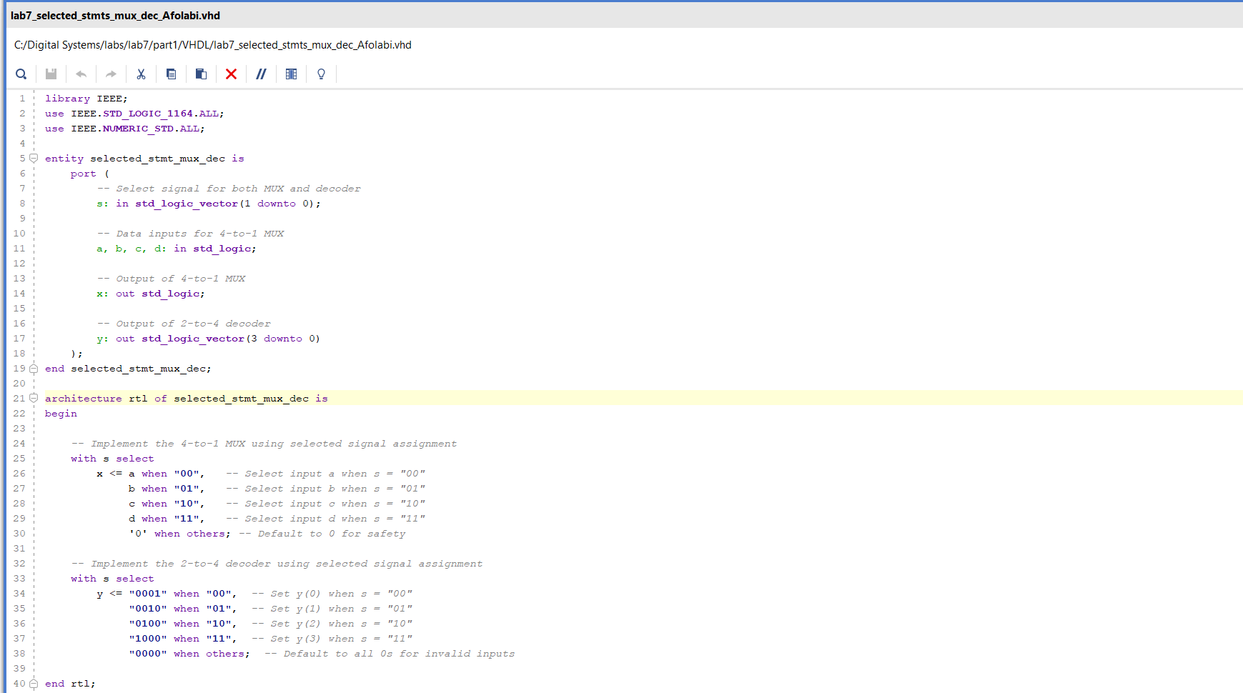

Part 2
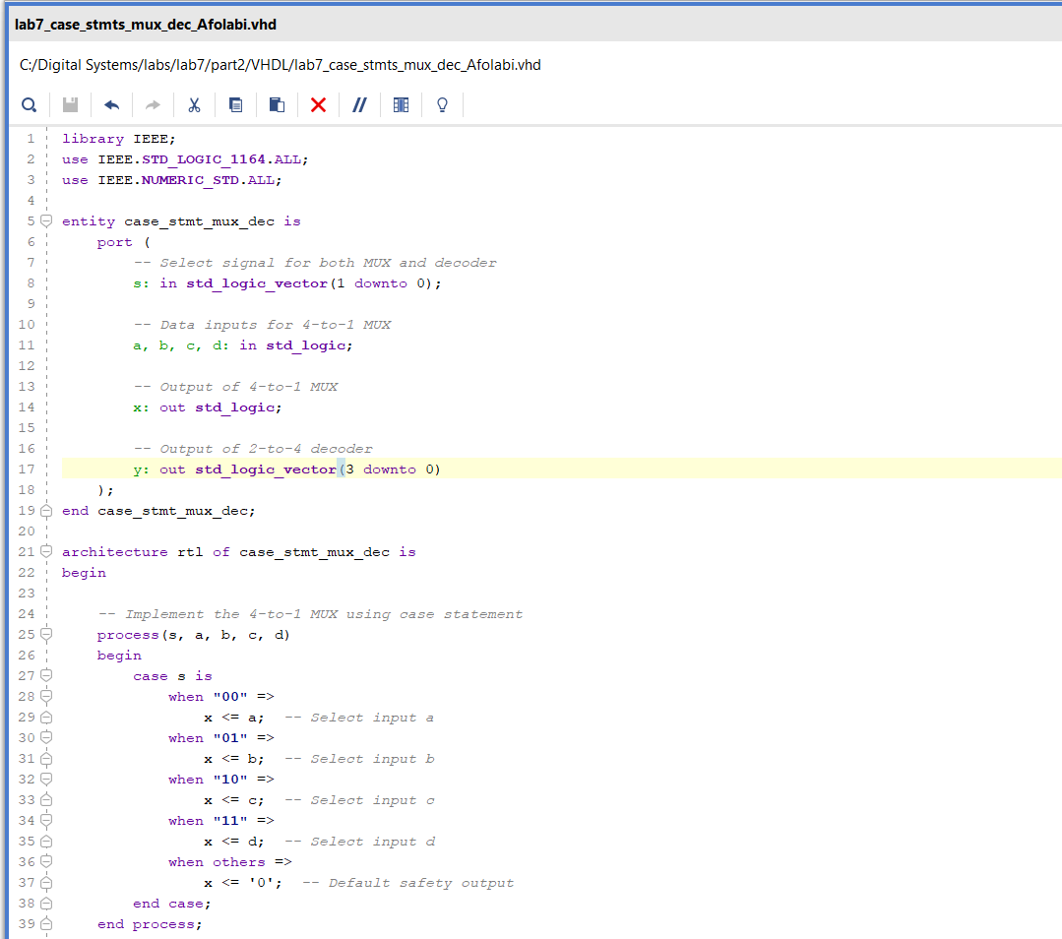
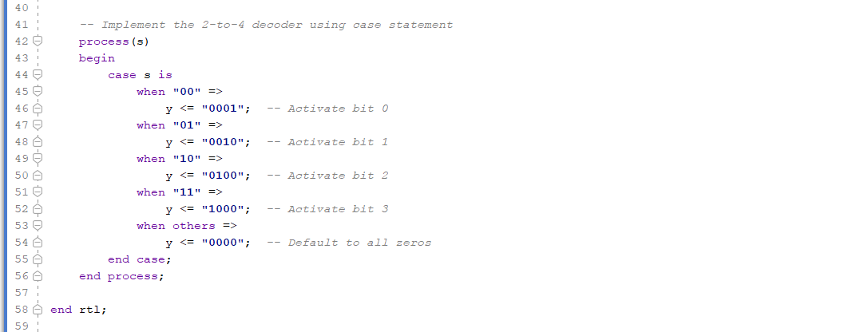
Comparison of Schematic:
Part 1:
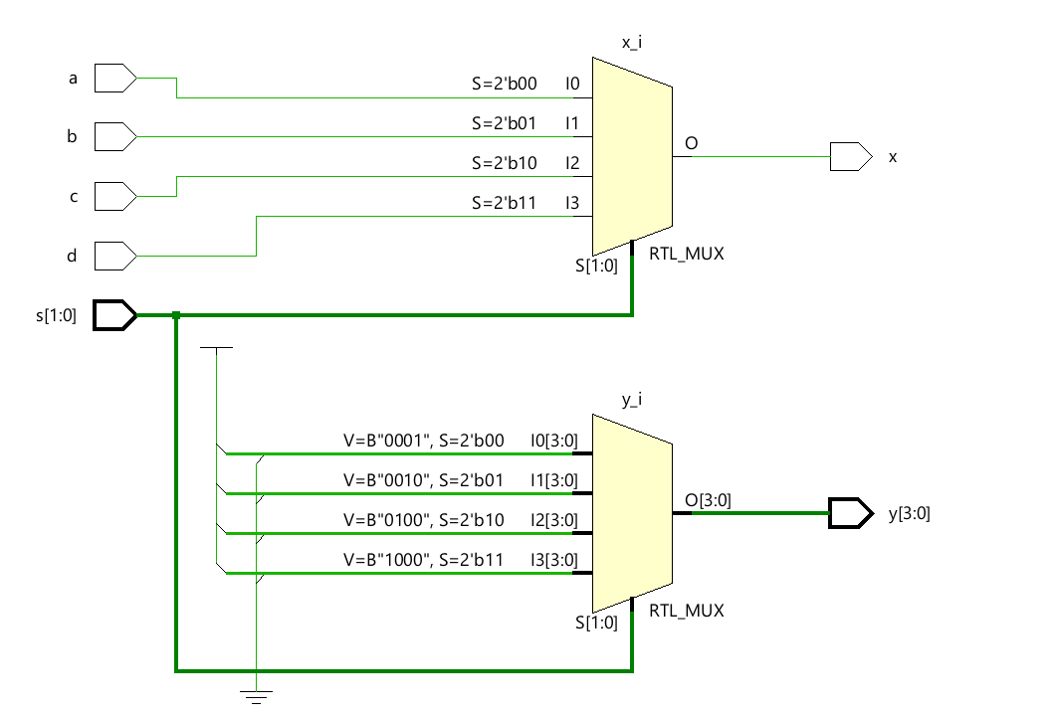
Part 2:
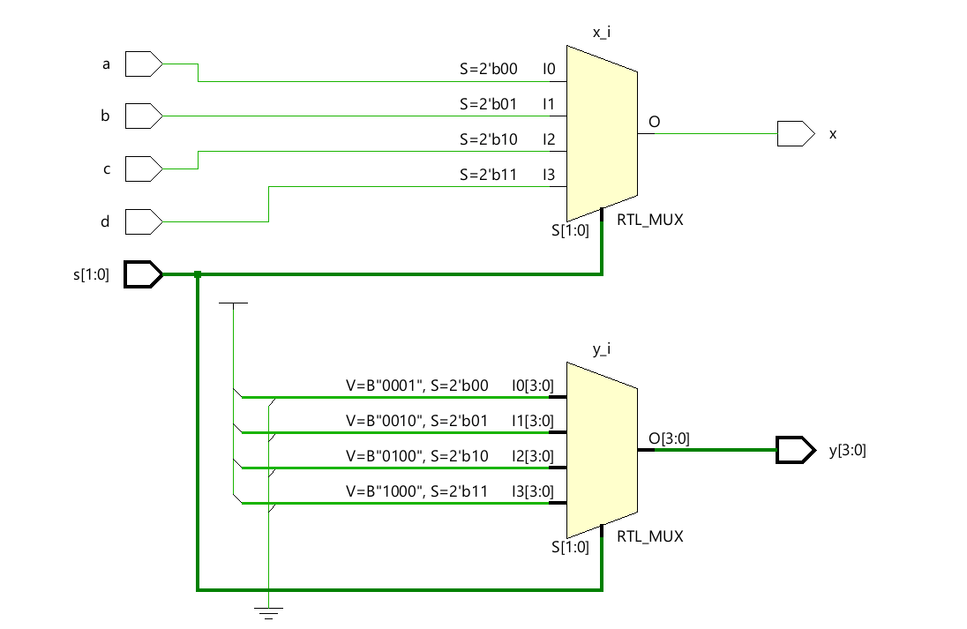

Upon analyzing the RTL schematics generated for both Part 1 (using selected signal assignment statements) and Part 2 (using case statements), it is evident that the two hardware designs are functionally and structurally identical. Both implementations correctly realize a 4-to-1 multiplexer and a 2-to-4 decoder based on the 2-bit select signal s[1:0].
In both schematics, the 4-to-1 MUX block (x_i) accepts the same four inputs (a, b, c, d) and routes the appropriate input to the output x based on the value of s. Similarly, the 2-to-4 decoder is implemented as another multiplexer (y_i) that outputs hardcoded one-hot values ("0001", "0010", "0100", and "1000") corresponding to the select input.
The connections, data paths, and output behavior are consistent across both designs. The only noticeable differences lie in Vivado’s internal labeling and port tagging conventions, such as instance names (RTL_MUX), signal routing labels, and generated net identifiers. These are purely cosmetic and do not affect the synthesized logic or behavior of the circuit.
In conclusion, both coding approaches—selected signal assignment and case statements—produce the same synthesized hardware when the logic structure is preserved. This highlights the flexibility of VHDL syntax in achieving equivalent digital designs through different styles of behavioral modeling.
Differences Between Selected Signal Assignment and Case Statements
In this lab, both the selected signal assignment and case statement methods were used to implement the same logic functions: a 4-to-1 multiplexer and a 2-to-4 decoder. While the final synthesized hardware circuits were structurally identical, the two VHDL approaches differ significantly in terms of syntax, usage context, and flexibility. The following points summarize the key differences between the two methods:
- Syntax and Structure
  - Selected signal assignment uses the with...select syntax and operates as a concurrent signal assignment outside of a process block.
  - Case statements use the case...when syntax and are written inside a process block, making them part of sequential logic.
- Execution Context
  - with...select is inherently concurrent, meaning it runs in parallel with other concurrent statements and does not require a sensitivity list.
  - case statements are sequential and must reside within a process, which includes a sensitivity list.
- Flexibility
  - case statements are more flexible, allowing for complex logic, multiple signal evaluations, and additional operations inside each branch.
  - with...select is less flexible and suited for straightforward one-to-one signal selection based on a single expression.
- Readability and Conciseness
  - with...select is typically more compact and readable for simple combinational logic such as MUXes and decoders.
  - case statements can become more verbose, but they offer better structure when multiple conditions and operations need to be handled.
- Synthesis Outcome
  - As shown in the RTL schematics generated from Vivado, both methods result in identical hardware structures for the same functional logic.
  - The only differences between the two outputs are in the naming and annotations automatically applied by Vivado.
Conclusion
In Lab 7, we successfully implemented a 4-to-1 multiplexer and a 2-to-4 decoder using two different VHDL coding methodologies: selected signal assignments and case statements. Each approach was used in separate parts of the lab to achieve the same functional goals, allowing for a direct comparison of both syntax styles and their impact on design behavior.
Through the Vivado design flow, we created two independent projects, wrote and compiled VHDL code, analyzed the resulting schematics, and confirmed the correctness of the hardware logic. The selected signal assignment method in Part 1 provided a concise and elegant structure ideal for simple, direct mappings between inputs and outputs. In contrast, the case statement method in Part 2 offered a more flexible and structured way to describe behavior, especially useful for complex or conditional logic within processes.
Despite the differences in syntax and style, both methods produced functionally and structurally identical RTL schematics, as verified using the Open Elaborated Design feature in Vivado. The only noticeable differences were in naming conventions and block tags automatically applied by Vivado during synthesis.
Ultimately, this lab deepened our understanding of VHDL behavioral modeling, design abstraction, and the impact of coding choices on digital system synthesis. It also reinforced our ability to evaluate, debug, and verify digital designs using both manual and tool-generated representations.

